Dayananda Sagar College of Engineering

**Department of Electronics and Communication Engineering**

**ShavigeMalleshwara Hills, Kumaraswamy Layout, Bangalore – 560 078.**

**(An Autonomous Institute affiliated to VTU, Approved by AICTE & ISO 9001:2008 Certified)**

***Accredited by National Assessment and Accreditation Council (NAAC) with ‘A’ grade***

**OPEN ENDED EXPERIMENT**

**INTEGRATED PRINCIPLES OF COMMUNICATION THEORY LAB**

|  |  |
| --- | --- |
| Program: B.E. | Branch: ECE |
| Course: Principles of Communication Theory | Semester : IV |
| Course Code: 22EC44 | Date: |

**A Report on**

**MATLAB Implementation of Pulse Position Modulation**

**&**

**Hardware Implementation of Square Law Modulator**

**Submitted by**

|  |  |  |  |
| --- | --- | --- | --- |
| **Sl.No.** | **USN** | **NAME** | **MARKS** |
| 1. | 1DS22EC054 | CHAITRA KRISHNA GOUDA |  |
| 2. | 1DS22EC057 | CHARAN. S |  |
| 3 | 1DS22EC058 | CHITHRASHREE .G. S |  |

Faculty In-charge

Prof. Naveen K. N.

Prof. Ravi Kumar S.

**Signature of Faculty In-charge**

**Software Simulation**

**Pulse position modulation :**

**Introduction:**

* Pulse Modulation:
* Transmits analog information by sampling continuous waveforms at regular intervals.
* Information transmitted only at sampling times with synchronizing signals.
* Original waveforms can be reconstituted from sample information at receiving end.
* Pulse Modulation types:
* Analog: sample amplitude is the variable.
* Digital: information is a code.
* Pulse Position Modulation (PPM): A method of Pulse Time Modulation
* PPM:
* Generated by changing pulse position in a fixed time slot.
* Amplitude and width of pulses kept constant, position varies.
* PPM advantages:
* Constant transmitter power output.
* Bandwidth efficiency.
* PPM disadvantage: requires transmitter-receiver synchronization.
* PPM obtained from Pulse Width Modulation (PWM).
* PPM used in:
* Wireless communication systems.
* Optical communication systems.
* Efficient data transmission over RF channels and fiber optic cables.
* High-speed data transmission with noise tolerance.

**Mathlab code:**

fc = 4000;

fm = 200;

Ac = 1;

Am=1;

t_end = 0.01;

fs = 10*fc;

t = 0:1/fs:t_end;

V_carrier = Ac* sawtooth(2*pi*fc*t);

V_mod = Am * sin(2*pi*fm*t);

V_pwm = (V_mod > V_carrier);

figure;

subplot(3,1,1);

plot(t, V_carrier);

xlabel('Time (s)');

ylabel('Amplitude (V)');

title('Carrier Signal');

subplot(3,1,2);

plot(t, V_mod);

xlabel('Time (s)');

ylabel('Amplitude (V)');

title(' Modulated Signal');

subplot(3,1,3);

plot(t, V_pwm);

xlabel('Time (s)');

ylabel('Amplitude (V)');

title('PWM Signal');

ylim([-0.1 1.1]);

pulse_width = 0.0001;

pwm_edges = find(diff(V_pwm) == 1);

ppm_positions = t(pwm_edges);

V_ppm=zeros(size(t));

for i = 1:length(ppm_positions)

start_idx = round(ppm_positions(i)*fs) + 1;

end_idx = round((ppm_positions(i) + pulse_width)*fs);

end_idx = min(end_idx, length(V_ppm));

V_ppm(start_idx:end_idx)=1;

end

figure;

subplot(3,1,1);

plot(t, V_ppm);

xlabel('Time (s)');

ylabel('Amplitude (V)');

title('PPM Signal');

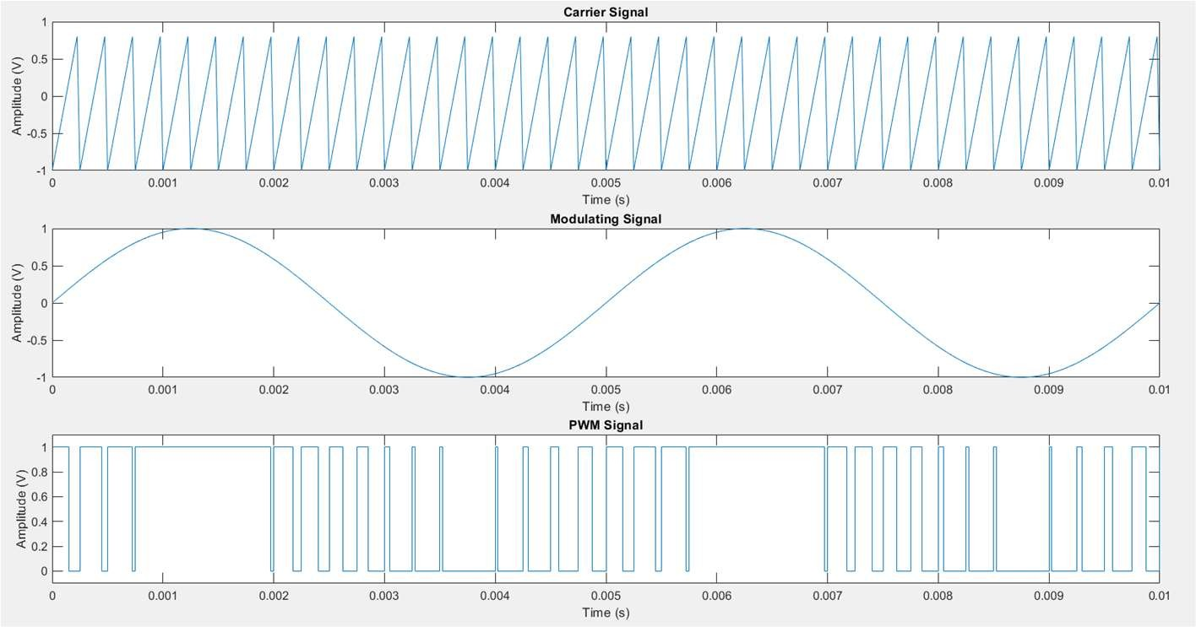**Output**:

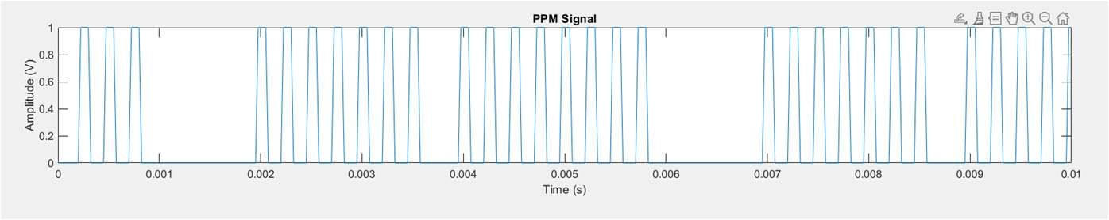

**Result:**

The experiment on Pulse Position Modulation (PPM) achieved successful generation and transmission of PPM signals. The signals were transmitted over a wireless communication channel and received with minimal distortion, demonstrating the technique's potential for reliable communication.

**Applications:**

* **Wireless Communication Systems**
* **Fiber Optic Communication**
* **Radar Systems**
* **Remote Sensing and Imaging**
* **Data Storage and Retrieval**
* **Threshold Detection**
* **Matched Filtering**
* **Timing Recovery**
* **Error Detection and Correction**

### Advantages of PPM:

* **Bandwidth Efficiency:** PPM can achieve higher data rates compared to other modulation techniques like Pulse Amplitude Modulation (PAM) for a given bandwidth.
* **Resistance to Noise:** PPM can be more robust against noise and interference because it relies on pulse timing rather than pulse amplitude.
* **Simplicity in Implementation:** PPM circuits can be simpler compared to other modulation schemes, making it cost-effective for certain applications.

### Limitations of PPM:

* **Timing Sensitivity:** PPM requires precise timing synchronization between the transmitter and receiver, which can be challenging in practical systems.
* **Lower Power Efficiency:** Transmitting sharp pulses in PPM can require higher peak power compared to other modulation techniques.

**Hardware Implementation**

**Square Law Modulator:**

**Introduction:**

Modulation is a fundamental technique in communication systems that involves altering a carrier signal's properties to encode information for transmission. It allows data to be transmitted efficiently over different media, such as radio waves, by varying one or more of the carrier signal's attributes, including amplitude, frequency, and phase. Modulation enables the transmission of digital or analog information over long distances while mitigating issues like interference and signal degradation.

A Square Law Modulator is a type of modulator used in analog communication systems to generate amplitude modulation (AM) signals. It operates based on the non-linear relationship between the input signal's amplitude and the output signal's power. In a square law modulator, the input signal is multiplied by itself, resulting in an output signal that contains both the original signal's frequency components and additional frequency components due to the nonlinear multiplication.

The key characteristics of a Square Law Modulator include:

1**. Nonlinear Operation**: The multiplication process introduces nonlinearity, causing the output to contain sum and difference frequency components.

2. **AM Signal Generation**: The modulator inherently generates amplitude modulation (AM) signals. The added frequency components carry the amplitude-modulated information.

3**. Efficiency:** Square law modulators are efficient in generating AM signals since the modulation process doesn't involve complex mathematical operations.

4. **Non-Idealities**: While useful for generating AM signals, square law modulators can introduce unwanted distortion and harmonics due to their nonlinear behavior.

5. **Envelope Detection:** Square law modulators are also utilized in envelope detection circuits, where the nonlinear operation is exploited to recover the envelope of an amplitude-modulated signal

**Circuit diagram:**

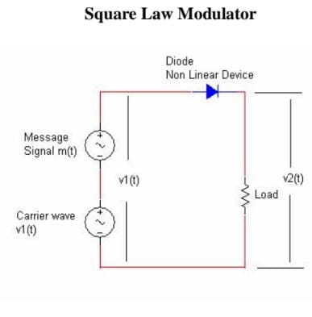

**Design:**

Designing a complete modulation and demodulation system using a Square Law Modulator and an Envelope Detector involves integrating both components to transmit and recover a modulated signal. Here's a simplified description of the process:

Modulation using Square Law Modulator:

1. Message Signal Source (Vin): Generate or provide the message signal that you want to modulate. This could be an audio signal or any analog signal you want to transmit.

2. Carrier Signal Source (Vc): Generate a high-frequency carrier signal that will be modulated with the message signal. This could be a sinusoidal waveform.

3. Square Law Modulator Circuit: Construct the Square Law Modulator circuit, as described previously, to mix the message signal with the carrier signal using the nonlinearity of the diode.

4. Output (Vmod): The output of the Square Law Modulator is the modulated signal (AM signal). It carries the information from the message signal within the variations of its amplitude.

**Components Used:**

* 1. Three 1kΩ resistors
  2. 1N4001 Diode
  3. Connecting wires
  4. Probes
  5. Oscilloscope

**Results :**

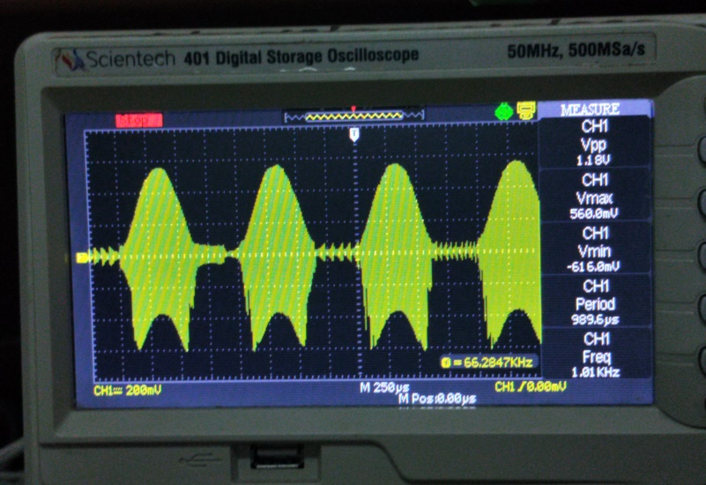

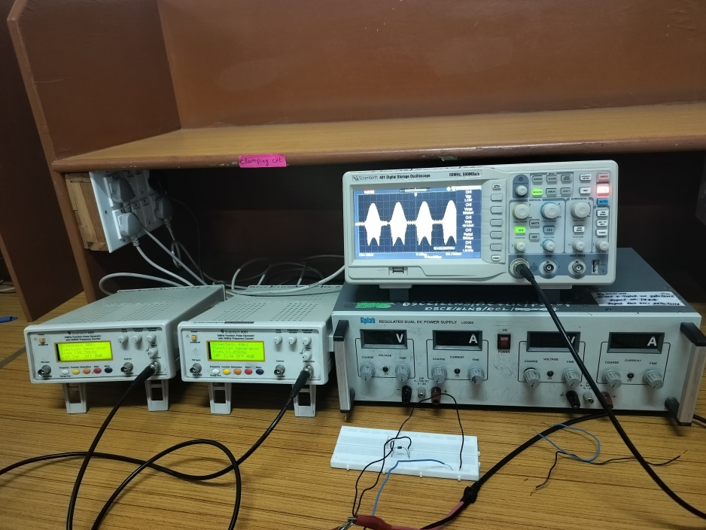

**Applications :**

The combined system of a Square Law Modulator finds applications in various domains Here are some applications:

1. **AM Radio Broadcasting**: The AM radio broadcasting industry relies on square law modulators and envelope detectors to transmit and receive audio signals. The modulator generates the AM signal for transmission, and the envelope detector recovers the original audio signal at the receiver's end
2. .**Wireless Communication:** In certain low-cost communication systems, such as short-range wireless microphones and intercoms, square law modulators and envelope detectors can be used for simple AM transmission and reception.
3. **Radio Frequency Identification (RFID**): In RFID systems, particularly those operating in the LF (Low Frequency) and HF (High Frequency) ranges, square law modulators and envelope detectors can be employed to encode and decode data on RFID tags and readers.
4. **Signal Generation and Detection for Testing**: The system can be utilized in laboratories and industries for generating and detecting modulated signals during testing and calibration processes. This can be particularly useful for testing radio receivers.
5. **Low-Cost Communication Systems**: In scenarios where, cost-effective communication is required and the emphasis is on simple modulation and demodulation, this system can be used

**Advantages:**

* **Simplicity:** Square law modulators are relatively simple to design and implement, making them a cost-effective solution for generating AM signals.
* **Non-linear Operation:** The non-linear characteristic of the square law device (such as a diode) naturally generates the desired AM signal when the input consists of both the carrier and the message signal.
* **Bandwidth Efficiency:** They can produce double sideband suppressed carrier (DSB-SC) AM signals, which are more bandwidth-efficient than standard AM signals with a full carrier.

**Disadvantages:**

* **Harmonic Distortion:** Due to the non-linear nature of the modulation process, square law modulators can produce harmonics and intermodulation products that need to be filtered out, which can complicate the design.
* **Power Inefficiency**: These modulators can be power-inefficient, as they may require more power to operate compared to other modulation techniques like balanced modulators.
* **Limited Linearity:** The performance of square law modulators is dependent on the linearity of the device used, and deviations from the ideal square law characteristic can degrade the quality of the modulated signal.
* **Noise Sensitivity**: They can be more sensitive to noise, which can affect the quality of the modulation, especially in low signal-to-noise ratio (SNR) environments.

.